1.REPORT VIEW

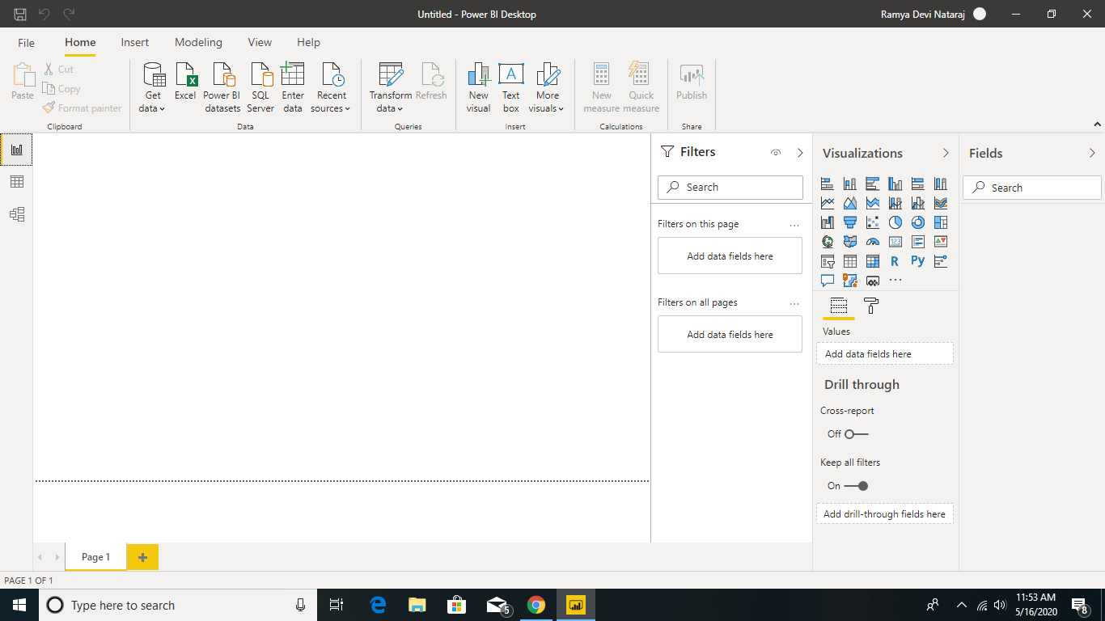

2.DATA VIEW

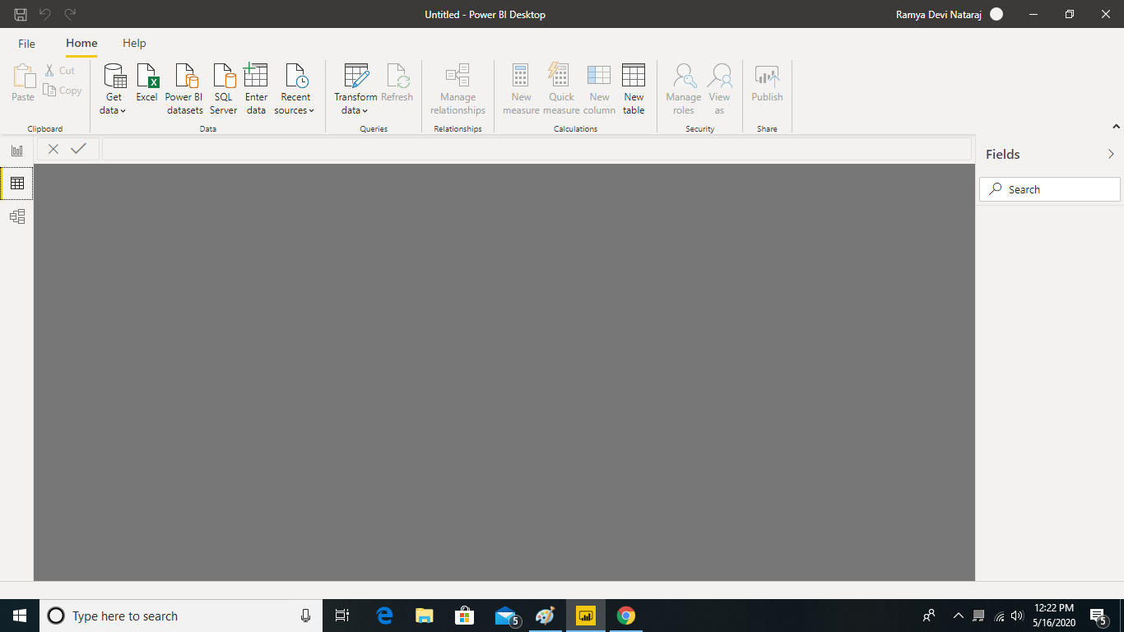

3.MODEL VIEW

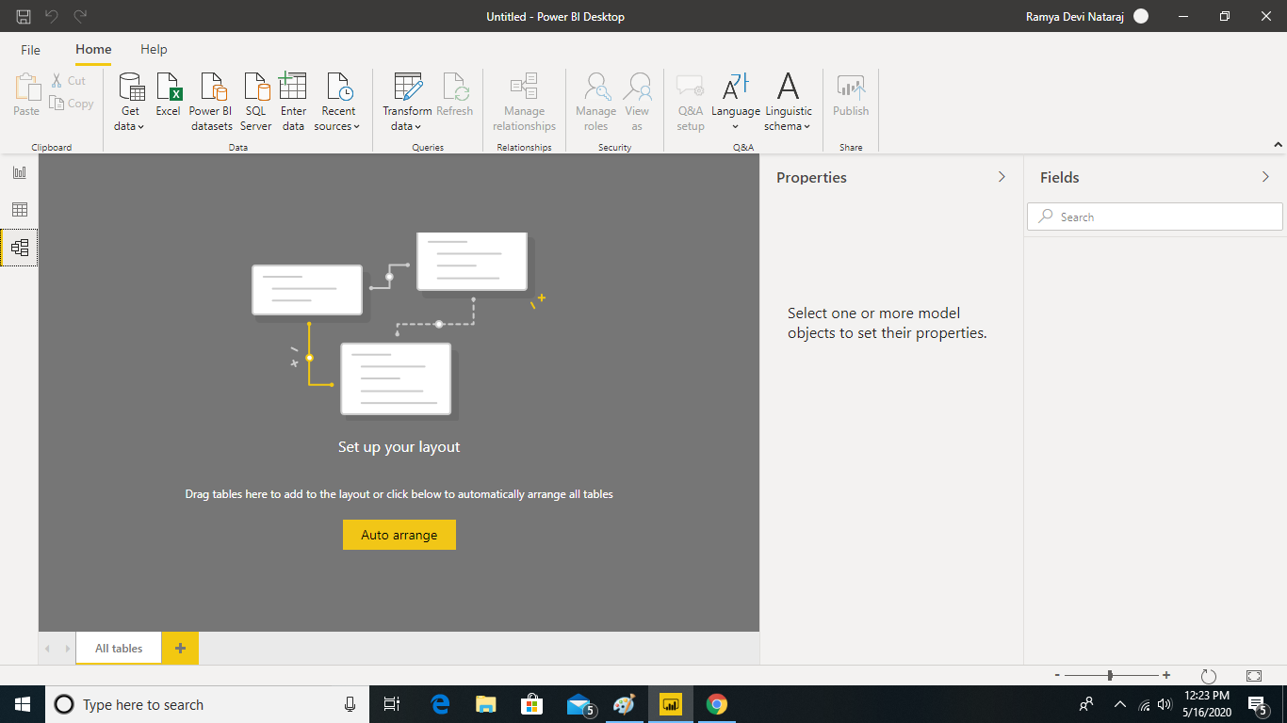

4.POWER QUERY EDITOR VIEW

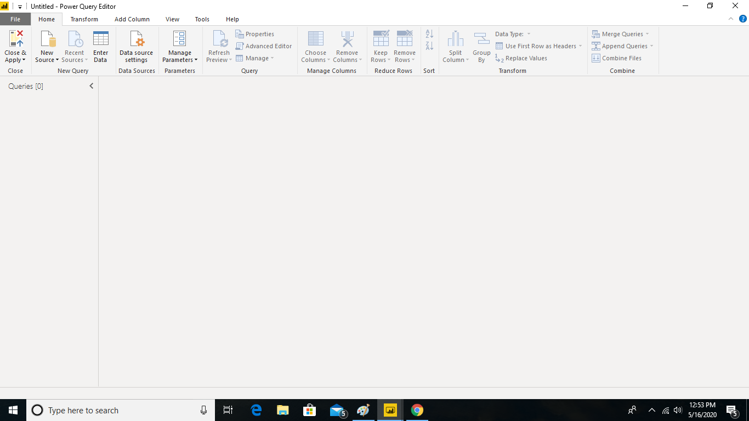

5.ADVANCED EDITOR VIEW

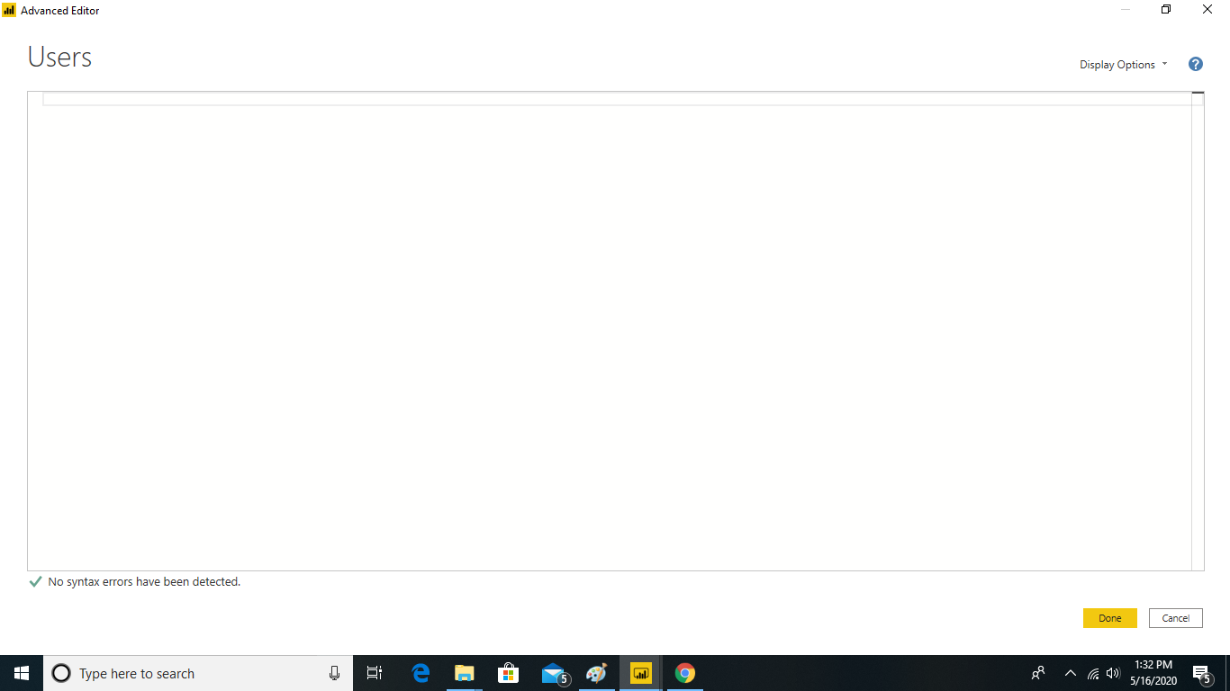

ADVANCED EDITOR VIEW